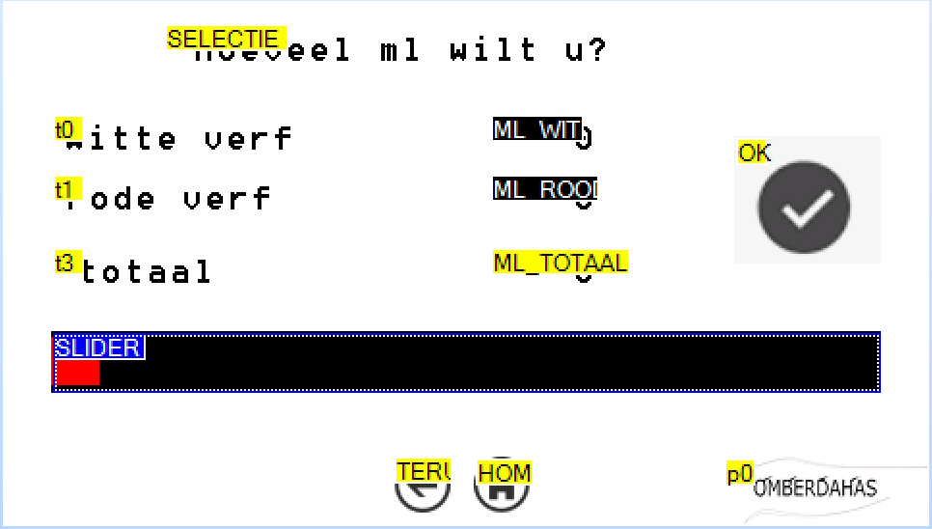

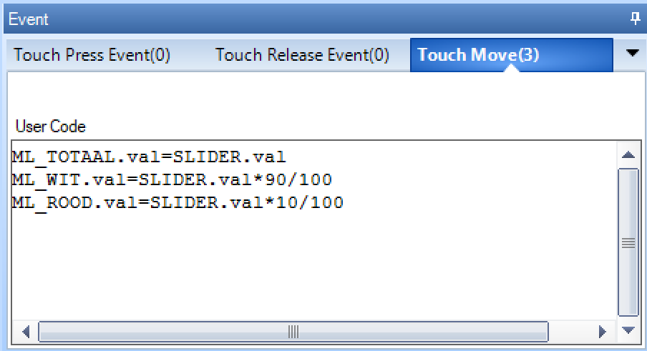

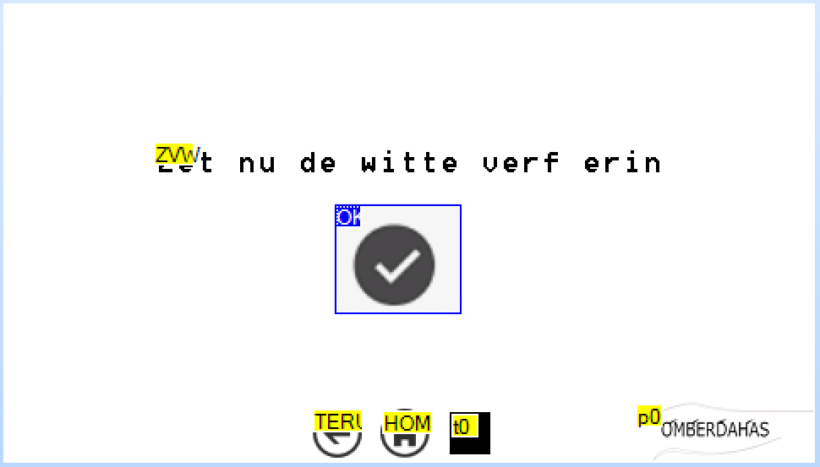

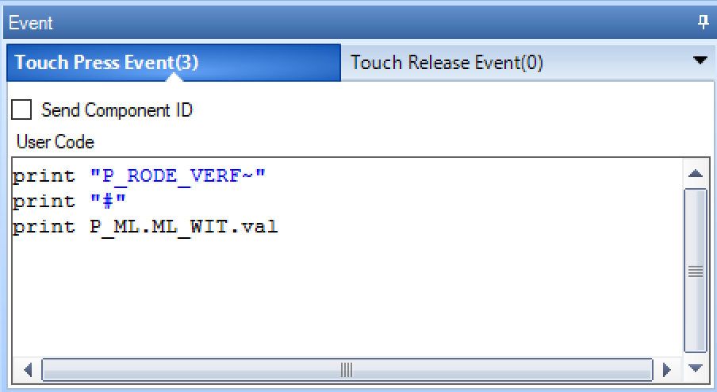

class Nextion

{

public:

Nextion();

~Nextion();

bool connect();

QVariant receive();

// this routine receives a Nextion print instruction

// it must be:

// - a text ending by a ~ sign, or

// - a number prefixed by a # sign

void sendPage( QVariant page);

void sendNumber( QString field, QVariant data);

void sendText( QString field, QVariant data);

private:

void send( QString data);

int m_fd;

};

int main(int argc, char *argv[])

{

…

nextion.sendPage( "P_MENU");

QVariant var;

QString str;

QString page;

forever {

// haal informatie van de nextion

var = nextion.receive();

// het moet goede informatie zijn

if ( var.isNull() )

continue;

…

}

…

}